**Problem Solving Process**

**Class 9**

**Lab 7**

|  |
| --- |
| Lab Objectives:  * Problem Solving with If..Else |

# What are if...else statement?

## Decision making is required when we want to execute a code only if a certain condition is satisfied.

## The if…elif…else statement is used for decision making.

# if Statement Syntax

if test expression:

statement(s)

## Here, the program evaluates the test expression and will execute statement(s) only if the text expression is True.

## If the text expression is False, the statement(s) is not executed.

# if Statement Flowchart

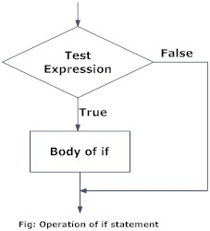

# Example: if Statement

num = 3

if num > 0:

print(num, "is a positive number.")

print("This is always printed.")

num = -1

if num > 0:

print(num, "is a positive number.")

print("This is also always printed.")

## When you run the program, the output will be:

3 is a positive number

This is always printed

This is also always printed.

## In the above example, num > 0 is the test expression.

## The body of if is executed only if this evaluates to True.

## When variable num is equal to 3, test expression is true and body inside body of if is executed.

## If variable num is equal to -1, test expression is false and body inside body of if is skipped.

## The print() statement falls outside of the if block (unindented). Hence, it is executed regardless of the test expression.

# Syntax of if...else

if test expression:

Body of if

else:

Body of else

## The if..else statement evaluates test expression and will execute body of if only when test condition is True.

## If the condition is False, body of else is executed. Indentation is used to separate the blocks.

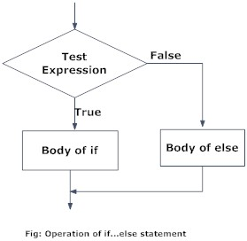

# Example of if...else

# Program checks if the number is positive or negative

# And displays an appropriate message

num = 3

# Try these two variations as well.

# num = -5

# num = 0

if num >= 0:

print("Positive or Zero")

else:

print("Negative number")

## [ Line starts with “#” denotes the comment, it’s not the part of executing a specific problem, comments only help people to understand the code ]

## In the above example, when num is equal to 3, the test expression is true and body of if is executed and body of else is skipped.

## If num is equal to -5, the test expression is false and body of else is executed and body of if is skipped.

## If num is equal to 0, the test expression is true and body of if is executed and body of else is skipped.

# Syntax of if...elif...else

if test expression:

Body of if

elif test expression:

Body of elif

else:

Body of else

## The elif is short for else if. It allows us to check for multiple expressions.

## If the condition for if is False, it checks the condition of the next elif block and so on.

## If all the conditions are False, body of else is executed.

## Only one block among the several if...elif...else blocks is executed according to the condition.

## The if block can have only one else block. But it can have multiple elif blocks.

# Flowchart of if...elif...else

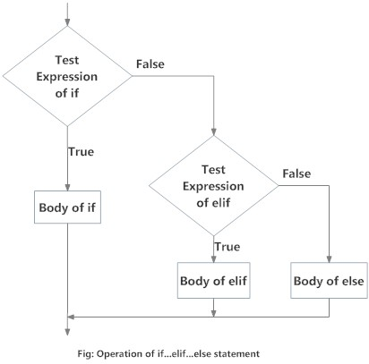

# Example of if...elif...else

# In this program,

# we check if the number is positive or

# negative or zero and

# display an appropriate message

num = 3.4

# Try these two variations as well:

# num = 0

# num = -4.5

if num > 0:

print("Positive number")

elif num == 0:

print("Zero")

else:

print("Negative number")

## When variable num is positive, Positive number is printed.

## If num is equal to 0, Zero is printed.

## If num is negative, Negative number is printed

# Nested if statements

## We can have a if...elif...else statement inside another if...elif...else statement. This is called nesting in computer programming.

## Any number of these statements can be nested inside one another. Indentation is the only way to figure out the level of nesting. This can get confusing, so must be avoided if we can.

# Nested if Example

## # In this program, we input a number

## # check if the number is positive or

## # negative or zero and display

## # an appropriate message

## # This time we use nested if

## num = float(input("Enter a number: "))if num >= 0:

## if num == 0:

## print("Zero")

## else:

## print("Positive number")else:

## print("Negative number")

## Output 1

Enter a number: 5

Positive number

## Output 2

Enter a number: -1

Negative number

## Output 3

Enter a number: 0

Zero